**Punto 2 – Algoritmo de Dijkstra**

- Tabla inicial -> Dw > Dv + c(v, w)

|  |  |  |  |
| --- | --- | --- | --- |
| V | Dv | Pv | Conocido |
| 1 | ∞ |  | 0 |
| 2 | ∞ |  | 0 |
| 3 | 0 | - | 1 |
| 4 | ∞ |  | 0 |
| 5 | ∞ |  | 0 |
| 6 | ∞ |  | 0 |
| 7 | ∞ |  | 0 |
| 8 | ∞ |  | 0 |

**RECORDAR QUE:**

**- se selecciona el vértice NO conocido de MENOR costo -> se marca como conocido y se evalúan los adyacentes NO CONOCIDOS -> Dw > Dv + c(v, w)**

**- Dv + c(v, w) -> SUMA DEL CAMINO TOTAL HASTA ESE VÉRTICE**

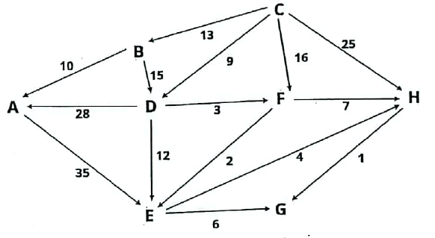

- Selecciono Vértice -> lo marco como conocido.

- actualizo costos y previos de vértices adyacentes (no conocidos):

* Dw > Dv + c(v, w) -> D(∞) > 0 + -> actualizo.

|  |  |  |  |  |
| --- | --- | --- | --- | --- |
| N° ITER | V | Dv | Pv | Conocido |
| 8° | A | ~~∞~~/~~37~~/23 | ~~D~~/B | ~~0~~/1 |
| 4° | B | ~~∞~~/13 | C | ~~0~~/1 |
| 1° | C | 0 | - | ~~0~~/1 |
| 2° | D | ~~∞~~/9 | C | ~~0~~/1 |
| 5° | E | ~~∞~~/~~21~~/14 | ~~D~~/F | ~~0~~/1 |
| 3° | F | ~~∞~~/~~16~~/12 | ~~C~~/D | ~~0~~/1 |
| 7° | G | ~~∞~~/20 | E | ~~0~~/1 |
| 6° | H | ~~∞~~/~~25~~/19 | ~~C~~/F | ~~0~~/1 |

